Non-Functional Execution Report

**Team Name: Zero To Hero**

# Introduction

## **Purpose of Load Test**

The goal of the Load test is to determine how well the Travel App application can manage a specific workload and stress level that are typical of real-world usage conditions. This will assist in figuring out whether the database can scale and perform well enough to meet the non-functional needs of the “Travel App” application.

## Test Environment

JMeter: To conduct our test and to make it more effective, we used JMeter.

## Test Data

* To plan and execute our test, we used JMeter for both execution and data gathering.
* The below steps were used to plan and carry out our test:
* Using the load test template, we first set up a test plan in JMeter.
* We made an HTTP request to select data from a specified table in JMeter.
* We added listeners to the test plan to record the result of the execution. such as summary report, Graphs result, view result in table and view result in tree.

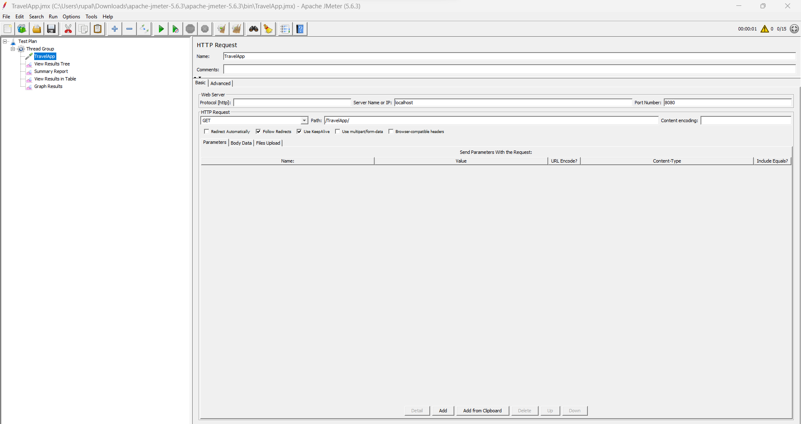

# Test results – Report.

|  |  |  |  |  |
| --- | --- | --- | --- | --- |
| Number of Users | Average | Std. Deviation | Error Percentage | Throughput Per Second |
| 15 | 4 | 1.11 | 0.00% | 16.0/sec |
| 50 | 4 | 1.46 | 0.00% | 50.8/sec |
| 100 | 4 | 1.24 | 0.00% | 100.8/sec |
| 150 | 2 | 0.65 | 0.00% | 142.5/sec |
| 500 | 1 | 2.93 | 0.00% | 505.6/sec |
| 750 | 8 | 12.37 | 0.00% | 849.4/sec |
| 1000 | 13 | 28.12 | 0.00% | 908.3/sec |
|  |  |  |  |  |

For 15 users:

View Result in Tree:

View Result in Summary Report:

View Result in Table:

View Result in Graph:

For 50 users:

View Result in Tree:

View Result in Summary Report

View Result in Tree:

View Result in Graph:

For 100 users:

View Result in Tree:

View Result in Summary Report:

View Result in Table:

View Result in Graph:

For 150 users:

View Result in Tree:

View Result in Summary Report:

View Result in Table:

View Result in Graph:

For 500 users:

View Result in Tree:

View Result in Summary Report:

View Result in Graph:

For 750 users:

View Result in Tree:

View Result in Summary Report:

View Result in Table:

For 1000 users:

View Result in Tree:

View Result in Summary Report:

View Result in Table:

View Result in Graph:

# Analysis and Findings

After conducting load testing, we were able to confirm that the application was functioning properly without any errors. All HTTP requests for 15 users, 50 users, 100 users, 150 users, 750 users, 1000 users have 0 % error.

In the load testing phase, we gradually increased the number of users interacting with the database. Our testing reports revealed that the Travel App application works well under different HTTP requests.